# Mobile App Scripting

EBENAZER NDAMULELO MUDAU

ST10447476

**Github link**

**https://github.com/ebenezerndamulelo/CHRISTOFFEL**

**youtube link**

<https://youtu.be/02FRhUwR9no?si=k5bThD2VQZz7Z0Ku>

Welcome to Christoffel's Culinary Companion

​

​” Your Personal Chef Experience”

​

​

​

​

Table of Contents

DESCRIPTION 2

Key features: 3

**1. Login/Signup Screen:** 3

**2. Home Screen:** 3

**3. Menu Management Screen (Christoffel only):** 3

**4. Client View/Checkout Screen:** 3

**5. Booking Screen:** 3

**6. Profile Screen:** 4

WireFrames 4

​ Benefits: 4

**1. For Christoffel**: 4

**2. For Clients**: 4

**3. Overall Advantages:** 4

Conclusion 5

​ References 5

​

​

​

​

# DESCRIPTION

Christoffel, a renowned private chef acclaimed for his personalized culinary experiences, brings his expertise to your fingertips with this innovative mobile application. Designed to enhance your dining

experience, our app offers a seamless interface between chef and client, available on both Android and Apple devices.

Our app is crafted to manage every aspect of your unique dining journey:

- Explore and customize menus tailored to your tastes and dietary needs

- Easily book Christoffel's services for your special occasions

- Access a vast database of gourmet recipes

- Track ingredients and discover new culinary inspirations

Whether you're planning an intimate dinner, a grand celebration, or seeking daily gourmet meals, Christoffel's app ensures a five-star dining experience in the comfort of your own home.

# Key features:

### 1. Login/Signup Screen:

- User authentication for Christoffel and clients

- Secure signup and login process

### 2. Home Screen:

- Complete menu display

- Course filtering (starters, main courses, desserts)

- Visually appealing layout

### 3. Menu Management Screen (Christoffel only):

- Add new menu items (name, description, ingredients, price, course)

- Upload and manage dish images

- Remove menu items

- Changes reflect on Home Screen

### 4. Client View/Checkout Screen:

- View complete menu

- Filter menu by course

### 5. Booking Screen:

- Book Christoffel's services

- Select date, time, and guest count

- Calendar integration for availability

- Secure payment system

### 6. Profile Screen:

- View/update user information

- Client feedback and rating system

# Wireframes

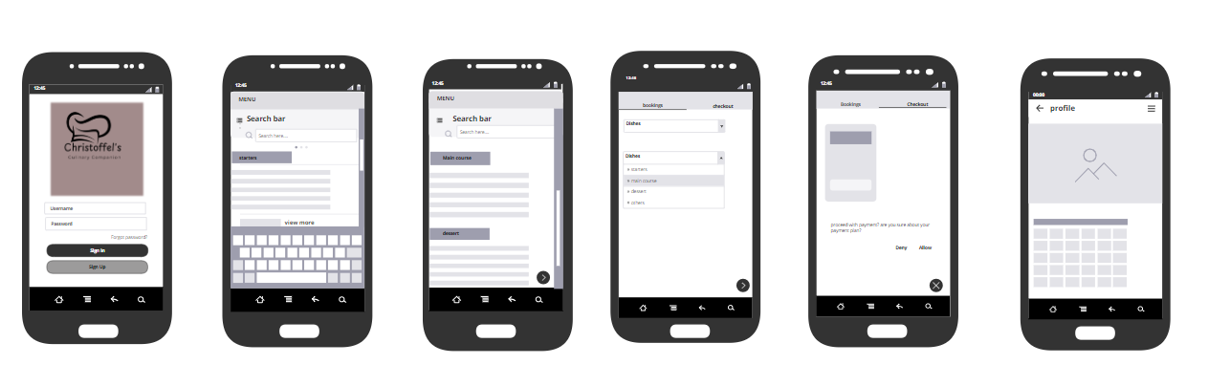

# ​ Benefits:

### 1. For Christoffel:

- Easy menu updates: Add, edit, or remove dishes quickly

- Efficient booking management: Track client requests and schedules

- Streamlined operations: Digital system for menu and reservations

### 2. For Clients:

- Convenient menu browsing: View and filter dishes easily

- Simple booking process: Schedule services with a few taps

- Personalized experience: Save preferences and provide feedback

### 3. Overall Advantages:

- Always up-to-date menu: Clients see the latest offerings

- Enhanced communication: Direct link between chef and clients

- Secure platform: Protected user data and transactions

- Improved service quality: Tailored dining experiences based on client profiles

This presentation highlights the key benefits for both Christoffel and his clients, emphasizing how the app improves the culinary service experience for everyone involved.

# Conclusion

Christoffel's Culinary Companion app is a huge step forward for private chef services, bridging the gap between gourmet knowledge and digital ease. This unique platform not only streamlines Christoffel's operations, but also improves the eating experience for his customers.

The app's user-friendly appearance, combined with its powerful capabilities, propels Christoffel to the top of modern culinary services. It demonstrates a commitment to excellence not only in the kitchen, but in all aspects of client engagement.

​

# ​ References

*Claude*. Available at: https://claude.ai/chat/d5de0caf-a4d5-4e5a-a3d9-811fa1b7346f (Accessed: 22 August 2024).

CACOO (no date a) *Redirect - nulab apps*. Available at: <https://cacoo.com/diagrams/dTxaIK3OFrAKK6au/9ADD1>  (Accessed: 22 August 2024).

​

​

​

​

​

​

​

​

​

​

​